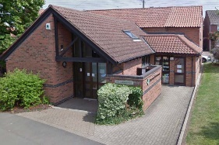


VALE MEDICAL GROUP NEWSLETTER

DECEMBER 2025

VALE MEDICAL GROUP

Stackyard Surgery
Tel: 01476 870900
Email – llricb-llr.stackyard.admin@nhs.net
Long Clawson Medical Practice
Tel: 01664 822214
Email – lcmp.admin@nhs.net
……………………………………………………..……………………………………………………..……………………………………………………..……………………………………………………..……………………………………………………..……………………………………………………..……………………………………………………..……………………………………………………..…………………………………………………….. …………………………………………………….. ……………………………………………………..……………………………………………………..

Friends and Family
www.valemedicalgroup.co.uk/about-us/friends-and-family-test/

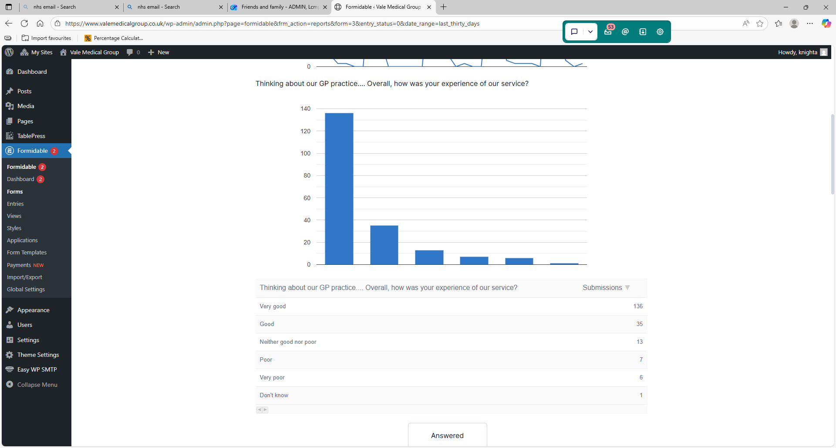
- Great support and care from Sarah the nurse.
- The service was very thorough with a helpful staff member.

DNAs (Did not attend)
DNA is someone who did not attend their doctor/nurse appointment and did not tell us beforehand.
The clinic was ready, the doctor and nurses were waiting, but the patient did not attend. Last month in September there were 128 DNAs at the Long Clawson Medical Practice and at the Stackyard Surgery, which patients did not attend.
If you are unable to attend your appointment, please let us now as Soon as you can so we can arrange for someone else to take your appointment.

How to enjoy Christmas food, drink and socialising without harming your heart
The holidays are the season of good cheer, and many of us are eating out or indulging at home more than we might do at other times. The good news is that you can still eat, drink and be merry without overdoing it. Here are some tips for enjoying this Christmas while keeping an eye on your waistline and health.
1.Don't overdo it
Whether you're eating out or at home, having a coffee or cup of tea while others have a pudding is a good way to round off a meal, or you could share a pudding with others.
2. Try to eat a bit less at other times
Have a lighter meal in the evening, like soup, salad or sandwich, if you had a big meal earlier in the day.
3. Check the menu in advance
4. Be demanding (politely) in restaurants
Don’t be afraid to ask the restaurant to adapt dishes.
5. Choose healthier options
6. Tuck into turkey - but beware of all the extras!
7. Fill up on vegetables
8. Cut back on Christmas nibbles
9. Be drink aware
10. Socialise in other ways
Instead of going out drinking, you could go for a winter walk with family and friends and enjoy the winter nature.

Vale Medical Group wishes all our patients and staff a Merry Christmas and a Happy New Year! Please see our website and Facebook for our Christmas/New Year opening times.


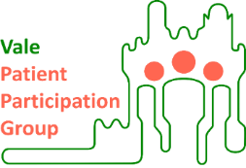
Patient participation groups are generally made up of a group of volunteer patients, the practice manager and one or more of the GPs from the practice. PPG meetings are held on a regular basis to discuss the services on offer, and how improvements can be made from the benefits of patients and the practice.
The VMG PPG currently has over 15 members and have meetings every three months, and our chair is Martin Fagan.
If you wish to make contact, please email info@valeppg.uk

WORLD AIDS DAY – 1st DECEMBER 2025
World AIDS Day is a global movement to unite people in the fight against HIV and AIDS. Since 1988, communities have stood together on World AIDS Day to show strength and solidarity against HIV stigma and to remember lives lost. In the UK, more than 105,000 people are living with HIV. Globally, an estimated 38 million people live with the virus. More than 35 million people have died of HIV or AIDS related illnesses over the past 40 years, making it one of the most destructive pandemics in history.
Medical advances mean people with HIV can expect a long and healthy life and that we have the tools to stop HIV transmissions for good. But HIV continues to be highly stigmatised and misunderstood. At National AIDS Trust, the UK’s HIV rights charity, are contacted weekly by people experiencing discrimination because of HIV, including in work, education, housing and even healthcare.
World AIDS Day exists to shine a light on the real experiences of people living with HIV today, while celebrating the strength, resilience and diversity of the communities most affected. It is a moment to inspire the leadership needed to create a future where HIV doesn’t stand in the way of anyone’s life.
For more information on HIV and world aids day you can visit: About - World AIDS Day HIV and AIDS - NHS

Christmas and Mental Health
Christmas can significantly impact mental health, leading to increased stress, anxiety, and depression. The holiday season is often associated with high expectations, social pressures, and feelings of isolation. It's crucial to recognize these triggers and find ways to cope, such as engaging in selfcare activities, seeking support, and prioritizing mental health during the festive season. Christmas could affect your mental health if you:
Wish you didn't have to deal with Christmas or find it stressful because of other events in your life, feel alone or left out because everyone else seems happy when you're not, feel frustrated by other people's views of a 'perfect' Christmas, if these feel different to your experiences. Have ideas about what Christmas should be like, feel as if you need to enjoy it or worry something will disrupt it. Feel like Christmas gives you something to focus on and look forward to and find it difficult when it's over. Look back at difficult memories, regret things about the past, or worry about the coming new year. For more information on dealing with worsening mental health during Christmas time you can visit: Christmas and mental health Mental health - NHS

RE-ORDER MEDICATION EARLY BEFORE CHRISTMAS
For those with repeat prescriptions, it is important to make sure you are well stocked going into the Christmas period.
Christmas is the busiest time of year for NHS services. To prevent becoming low on supply for your medical conditions; please order your prescriptions as early as possible.
NHS 111 phone lines tend to see a large increase in patients calling about their prescriptions during a bank holiday. Christmas is no different – in fact, it significantly outweighs every other holiday.
Hours are likely to be shortened for pharmacies and GP surgeries throughout the Christmas period, so it will be more challenging than usual to access medication at short notice.
Please make sure you are ordering Christmas Prescriptions before Monday 15th December in time for Christmas.

National Grief Awareness Week 2nd to 8th December 2025
National Grief Awareness Week aims to raise awareness of grief, and to help to normalise conversations around it. Grief affects people in different ways. If your partner, relative or friend has died, you may find it hard to cope with your emotions and the practical things you have to do. Grief is a word for some of the feelings you may have after the death of someone close to you. There is no right or wrong way to grieve. Some people describe being overcome or frightened by their feelings; others say they feel numb.
The thoughts and feelings you have will vary. Sometimes, they may be very intense and stop you doing things. At other times, they may be in the background, and you can still do your day-to-day activities.
How you feel and react may depend on different things, such as: the relationship you had with the person who died, if the death was expected, how they died, any previous experience of death you have had.
Your feelings may change day-to-day or even hour to hour. It is quite normal to have ups and downs.
More information and support is available on the coping with bereavement hub including support with grief.
If you continue to be overwhelmed by your feelings, it is important to get the right help and support. You should talk to your GP or another health or social care professional.

…………………………………………………………………………… Vale Medical Group … ………………….
………………………………………………………

